**Data Preparation and Statistical Analysis in a Study on Cow's Milk Allergy Treatment**

**Data Preparation**

Data were collected from a total of 214 patients. These data were sent to Microsoft Excel for preparation for the statistical analyses. The data set included columns for patients’ age at baseline, gender, and endotype. It also included columns representing data on pre- and post- TIP treatment for the following variables: Total IgE, Eosinophil, Cow Milk IgE, Boiled Cow Milk IgE, Bos D4, Bos D5, Bos D8, and Milk IgG 4. The data were checked for erroneous responses and missing values. All cells with values ‘NA’ were replaced with black cells so that the variables be read as numerical variables when conducting the statistical analyses. It was found that the columns representing pre- and post-intervention data on Total IgE, Eosinophil, Cow Milk IgE, and Boiled Cow Milk IgE contained missing values. However, no cases with missing values were excluded from the data as it was planned to use a pairwise deletion method to treat the incomplete responses. These data were loaded into R version 4.2.2 for statistical analysis.

**Summary Statistics**

Data from a total of 214 patients were included for statistical analyses. All patients in the cohort had a recent severe anaphylactic reaction to cow's milk. The age of the patients at baseline varied from 1 to 19 years and had an average of 5.60 years. Of the 214 patients, 33.6% (*n* = 72) were female and 66.4% (*n* = 142) were male. The frequencies of types 1, 2, 3, 4, and 5 endotypes were 57 (26.6%), 124 (57.9%), 6 (2.8%), 4 (1.9%), and 2 (0.9%), respectively, and 21 patients were non-typable. Table 1 provides the descriptive statistics for the variables of the study. From pre- to post-treatment, the mean Total IgE increased from 573.93 to 784.56, and the mean Milk Ig G4 increased from 3.08 to 7.17. However, the mean Eosinophil decreased from 558.38 to 409.26, the mean Cow Milk IgE decreased from 16.91 to 9.10, the mean Boiled Cow Milk IgE decreased from 12.89 to 6.03, the mean Bos D4 decreased from 7.38 to 3.52, the mean Bos D5 decreased from 6.79 to 3.16, and the mean Bos D8 decreased from 13.55 to 6.62.

**Table 1**

*Descriptive Statistics for the Study Variables*

|  |  |  |  |  |  |  |  |
| --- | --- | --- | --- | --- | --- | --- | --- |
| Variable | *n* | *Min* | *Max* | Median | *IQR* | Mean | *SD* |
| Pre Total IgE | 206 | 7.56 | 5960 | 321.50 | 546.50 | 573.93 | 788.09 |
| Post Total IgE | 206 | 18.2 | 13510 | 389.00 | 712.50 | 784.56 | 1284.05 |
| Pre Eosinophil | 208 | 10 | 4241 | 370.00 | 504.50 | 558.38 | 590.28 |
| Post Eosinophil | 208 | 10 | 2530 | 355.00 | 360.00 | 409.26 | 298.09 |
| Pre Cow Milk IgE | 141 | 0 | 101 | 2.71 | 15.71 | 16.91 | 29.25 |
| Post Cow Milk IgE | 141 | 0 | 100 | 1.59 | 8.20 | 9.10 | 17.61 |
| Pre Boiled Cow Milk IgE | 213 | 0 | 101 | 1.90 | 10.77 | 12.89 | 25.04 |
| Post Boiled Cow Milk IgE | 213 | 0 | 100 | 0.80 | 4.01 | 6.03 | 14.25 |
| Pre Bos D4 | 214 | 0 | 100 | 0.52 | 4.35 | 7.38 | 17.85 |
| Post Bos D4 | 214 | 0 | 69.7 | 0.28 | 2.50 | 3.52 | 8.91 |
| Pre Bos D5 | 214 | 0 | 100 | 0.47 | 3.05 | 6.79 | 17.95 |
| Post Bos D5 | 214 | 0 | 87.3 | 0.23 | 1.36 | 3.16 | 9.58 |
| Pre Bos D8 | 214 | 0 | 101 | 1.25 | 9.80 | 13.55 | 26.46 |
| Post Bos D8 | 214 | 0 | 100 | 0.61 | 3.18 | 6.62 | 16.87 |
| Pre Milk Ig G4 | 214 | 0 | 30 | 0.34 | 1.90 | 3.08 | 6.46 |
| Post Milk Ig G4 | 214 | 0 | 30 | 1.72 | 7.74 | 7.17 | 10.30 |

**Model 1 (Comparisons)**

The first aim of this study was to assess if there was a statistically significant difference between IgE levels pre- and post-treatment. For this purpose, a total of eight comparisons were made. It was planned to utilize the dependent samples *t*-test to assess all these differences in the pre- and post-treatment values. Before running these analyses an evaluation of their assumptions was conducted.

***Assumption Checking***

The assumptions of the dependent samples *t*-test to check were as follows: 1) an absence of significant outliers in the differences between pre- and post-treatment values, and 2) normality of the differences between pre- and post-treatment values (Lund, 2021). The first assumption was assessed using boxplots of the differences in the paired observations for each IgE (see Figure 1).

From these boxplots, it can be seen that the differences in the paired values for all eight IgEs contained multiple extreme variables deviating far away from the general pattern of the observations. Thus, these plots provided evidence that the absence of outliers’ assumption was violated for all eight dependent samples *t*-tests.

**Figure 1**

*Assessment of the Absence of Extreme Outliers’ Assumption of the Dependent Samples t-Tests*

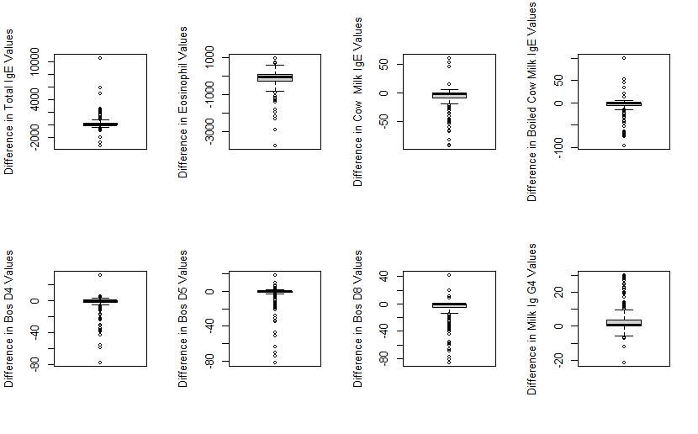

The second assumption to evaluate was the normality of the differences in the paired observations for each IgE. The Shapiro-Wilk test of normality was employed to address this assumption (see Table 2). The null hypothesis of this test is that the differences in the pre- and post-treatment values are normally distributed. As can be seen from Table 2, there were significant deviations from the normality assumption for all dependent samples *t*-tests as the *p*-value associated with the Shapiro-Wilk statistic for each IgE was less than .05.

**Table 2**

*Assessment of the Normality Assumption of the Dependent Samples t-Tests*

|  |  |  |
| --- | --- | --- |
| Variable | Shapiro Wilk Statistic | *p*-value |
| Difference in Total IgE Values | .528 | < .001 |
| Difference in Eosinophil Values | .732 | < .001 |
| Difference in Cow Milk IgE Values | .687 | < .001 |
| Difference in Boiled Cow Milk IgE Values | .640 | < .001 |
| Difference in Bos D4 Values | .512 | < .001 |
| Difference in Bos D5 Values | .425 | < .001 |
| Difference in Bos D8 Values | .588 | < .001 |
| Difference in Milk Ig G4 Values | .716 | < .001 |

***Results***

Considering that there were substantial departures from both the normality and absence of outliers’ assumption of all eight independent samples *t*-tests, these analyses were deemed unreliable to assess the differences in the pre and post-treatment IgE values. Thus, the Wilcoxon signed-rank test was utilized as the non-parametric counterpart to the dependent samples *t*-test to assess the difference between pre-and post-treatment values. This non-parametric procedure is robust to the presence of outliers in the data and violations of the normality assumption as it does not make assumptions about the distribution of the data.

The results of the Wilcoxon signed rank test are summarized in Table 3. These results indicated that there were significant differences between pre-and post-intervention value for all eight IgEs (*p* < .05). The median of Total IgE increased from 321.50 to 389.00, and the median of Milk Ig G4 increased from 0.34 to 1.72. Both these increases in the medians were statistically significant. The median of Eosinophil decreased from 370.00 to 355.00, the median of Cow Milk IgE decreased from 2.71 to 1.59, the median of Boiled Cow Milk IgE decreased from 1.90 to 0.80, the median of Bos D4 decreased from 0.52 to 0.28, the median of Bos D5 decreased from 0.47 to 0.23, and the median of Bos D8 decreased from 1.25 to 0.61. Based on the results of the Wilcoxon signed rank tests, all these decreases in the medians were statistically significant.

**Table 3**

*Assessing Differences Between Pre- and Post-Intervention IgE Values*

|  |  |  |  |
| --- | --- | --- | --- |
| Variable | *N* | Wilcoxon Test Statistic | *p*-value |
| Total IgE | 206 | 7816.5 | .001 |
| Eosinophil | 208 | 13172 | .001 |
| Cow Milk IgE | 141 | 7127 | < .001 |
| Boiled Cow Milk IgE | 213 | 16341 | < .001 |
| Bos D4 | 214 | 11997 | < .001 |
| Bos D5 | 214 | 12070 | < .001 |
| Bos D8 | 214 | 15540 | < .001 |
| Milk Ig G4 | 214 | 2839.5 | < .001 |

**Figure 2**

*Changes in Bos D4 Values from Pre to Post-Intervention for Individual Patients*

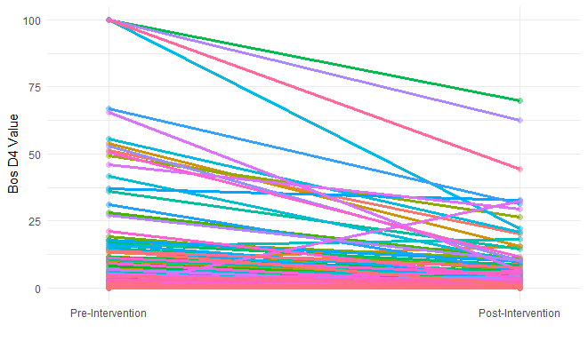

**Figure 3**

*Changes in Bos D5 Values from Pre to Post-Intervention for Individual Patients*

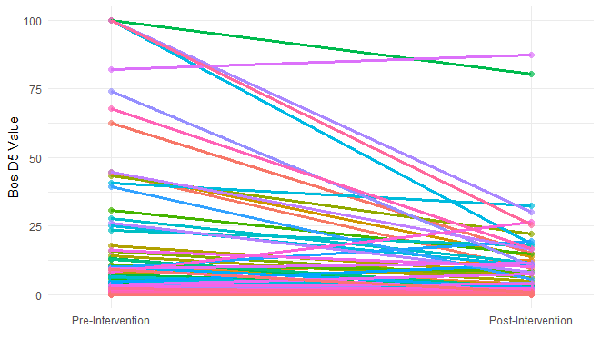

**Figure 4**

*Changes in* *Milk IgG4 Values from Pre to Post-Intervention for Individual Patients*

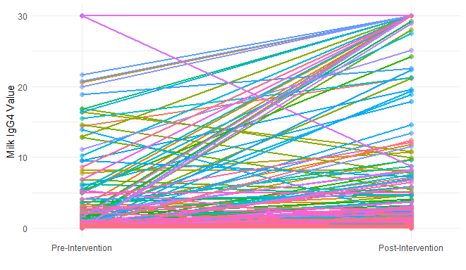

**Model 2 (Mixed Effects)**

This study also aimed to conduct mixed-effects modeling using a subject-specific approach to assess for patterns in the changes in the pre- to post-treatment values in Bos D8. In this analysis, pre-treatment Bos D8 was entered as the covariate, and post-treatment Bos D8 was entered as the outcome variable. The researcher was especially interested in examining patients with higher levels of Bos D8 (greater than 10) as well as patients with the highest levels of Bos D8 (near 100). Before running this analysis, the data were examined for the presence of patterns in changes in Bos D8 from pre- to post-treatment for individual patients (see Figure 5). This plot indicates downward patterns for most of the patients. The slope of individual trajectories seems to be steeper for higher values on pre-intervention Bos D8, which could be indicative of the presence of patterns in the data.

**Figure 5**

*Changes in Bos D8 Values from Pre to Post-Intervention for Individual Patients*



Based on the examination of the individual trajectories of Bos D8 pre- to post-treatment as well as the aim of the researcher to examine patients with higher levels of Bos D8 and patients with the highest levels of Bos D8, the data were grouped into four categories (see Table 4). A grouping variable was created based on these groups and was used in the mixed effects modeling approaches to assess for patterns in patients with different pre-intervention Bos D8 levels.

**Table 4**

*Frequency Table for the Grouping Variable*

|  |  |  |  |
| --- | --- | --- | --- |
| Group | Pre-Intervention Bos D8 Value | Frequency | Percent |
| 1 | [0,10) | 160 | 74.8 |
| 2 | [10,25) | 19 | 8.9 |
| 3 | [25,90) | 22 | 10.3 |
| 4 | [90, 101] | 13 | 6.1 |
| Overall | [0,101] | 214 | 100 |

Two mixed-effects models will be assessed in this study; a random intercept and fixed slope model (Model 1), and a random intercept and random slope model (Model 2). The model specification procedure involved the specification of a family distribution and a link function. The family distribution is selected based on the properties of the chosen probability distribution for the data. The choice of the link function depends on the appropriateness of the fit of the model to the data (Ng & Cribbie, 2017).

The first step of the model specification procedure was to determine an appropriate family of distributions for mixed-effects modeling. For this purpose, the Cullen and Frey graph was created to compare several potential theoretical distributions that could present the data well (see Figure 6). Among the theoretical distributions, the distribution of the data seemed to be closest to a gamma distribution. The data seem to be far away from being normally distributed. Another support for the gamma family specification compared to other distributions such as the normal distribution was that the outcome variable of post-treatment Bos D8 only takes non-negative values.

**Figure 6**

*Examining the Distribution of the Outcome Variable Using the Cullen and Frey Graph*

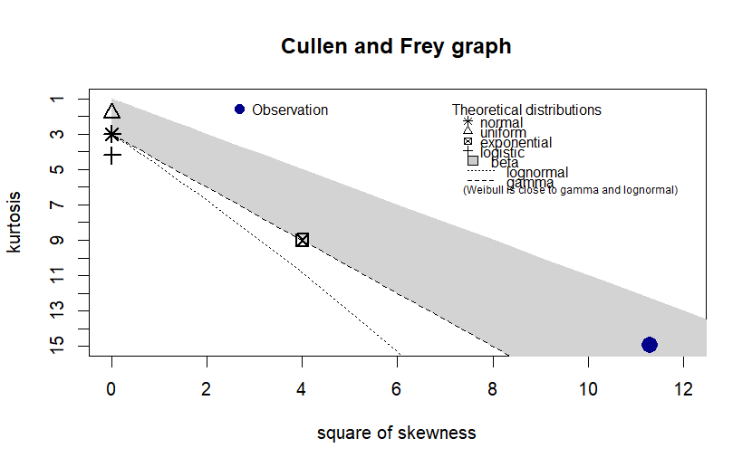

It was further examined whether a gamma distribution represented the data well by assessing the empirical versus the theoretical densities, the empirical versus the theoretical cumulative distribution functions, the Q-Q plot, and the P-P plot for the gamma distribution (see Figure 7). These plots suggested that the distribution of the outcome variable is not substantially different from a theoretical gamma distribution and therefore a gamma specification seemed appropriate for mixed-effects modeling. Hence, the researcher decided to use a gamma specification in the mixed-effects models. However, provided that the gamma distribution only takes positive values and that some values on both the pre- and post-treatment Bos D8 were zero, an adjustment was made to the data by adding 0.1 to each value. To account for this adjustment, when the model was used for prediction purposes, the 0.1 value would be subtracted from the predicted values.

**Figure 7**

*Comparing the Empirical and Theoretical (Gamma) Distributions*

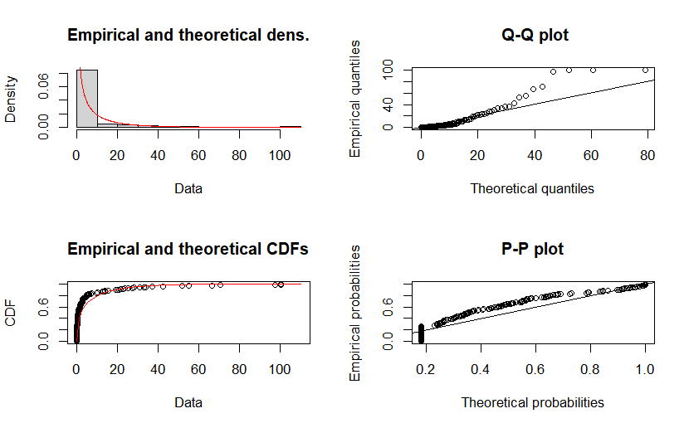

The next step was to determine an appropriate link function specification for the mixed effects models. This was done by comparing the appropriateness of fit of the models conducted with the log, inverse, and identity link functions using the plot of residuals versus fitted values. Substantial patterns were observed for both Model 1 and Model 2 when estimated based on the inverse and identity link functions. This indicated poor fits of the models to the data when the inverse and identity link functions were used. However, when the log link function was applied, a good fit was observed for Model 2 as the residuals seemed to be randomly dispersed across the predicted values and there did not seem to be substantial patterns in the observations (see Figure 9).

**Figure 8**

*Plot of Residuals Versus Fitted Values for the Random Intercept Fixed Slope Model*

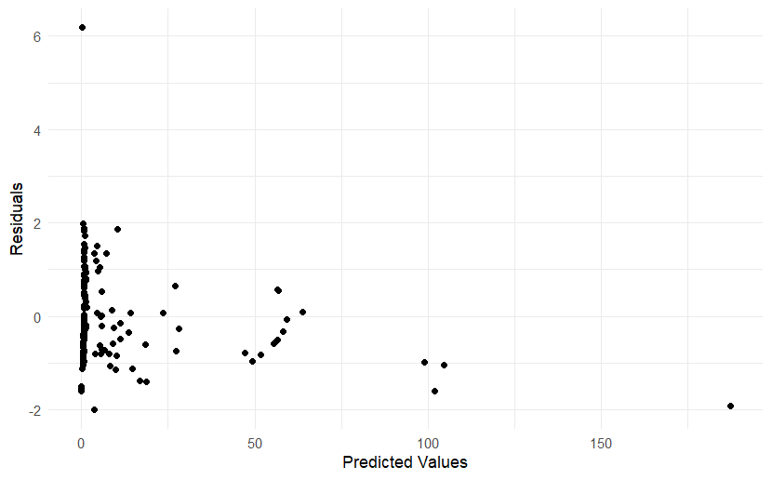

**Figure 9**

*Plot of Residuals Versus Fitted Values for the Random Intercept Random Slope Model*

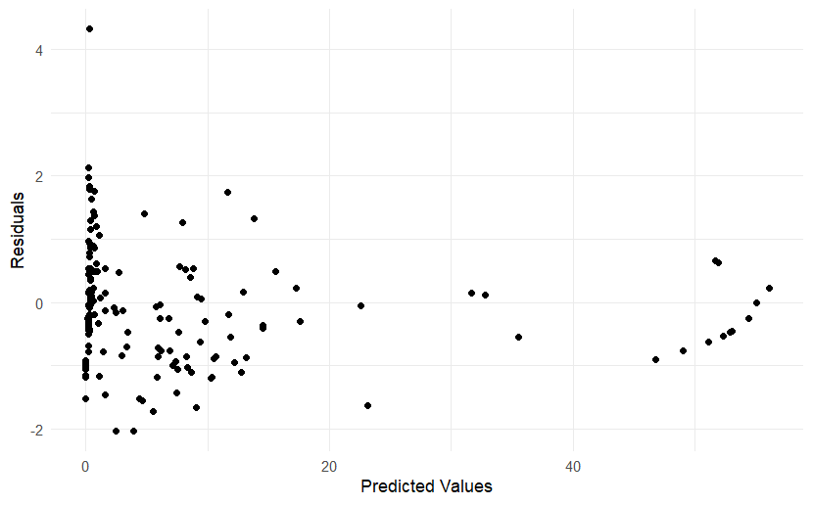

Summary statistics for Model 1 and Model 2 are provided in Table 5. The likelihood ratio (*LR*) test was utilized to compare the specified models with a null model that only assumed random intercepts. As shown in Table 5, in terms of model fit, both Model 1 (*χ*2(1) = 40.170, *p* < .001) and Model 2 (*χ*2(3) = 146.71, *p* < .001) performed significantly better than the random intercept only model.

**Table 5**

*Summary Statistics for the Random Intercept and Fixed Slope (Model 1), and the Random Intercept and Random Slope (Model 2) Modelsa*

|  |  |  |
| --- | --- | --- |
| Model Term Estimates on the Log Scale | Model 1 | Model 2 |
| σs | 3.274 | 1.483 |
| σt:s | - | 0.040 |
| Σ | 8.072 | 1.734 |
| μ(SE), p-value | -0.757 (1.071), *p* = .480 | 0.598 (0.622), *p* = .336 |
| β(SE), p-value | 0.074 (0.018), *p* < .001 | 0.138 (0.084), *p* = .098 |
| LR test | Model 1 Versus Null Modelb | Model 2 Versus Null Modelb |
|  | *χ*2(1) = 40.170, *p* < .001 | *χ*2(3) = 146.71, *p* < .001 |

aThe generalized linear mixed modeling procedure with the specification of gamma family and log link; bModel was compared to the reduced model. The null model assumed no intervention effect (random intercept only) by calling ANOVA on the fitted object and performing the LR test on variance components using the *χ*2 distribution; *σ* =standard deviation for random effects on log scale; *σs*=subject standard deviation; *σt:s*=effect of difference from pre to post variability across groups; *β* =error standard deviation; *μ*=overall intercept.

Table 6 reports the intercept and slope coefficients on the log scale for Model 1 and Model 2 for each group. Since a random intercept and fixed slope specification was used for Model 1, the intercept coefficient varied across groups, while the slope coefficient was constant across groups and was therefore equal to the overall slope reported in Table 5. However, for the second model, both intercept and slope coefficients differed across the groups, indicating different patterns from pre- to post-intervention for each group.

**Table 6**

*Intercept and Slope Coefficients* *on the Log Scale for Each Group*

|  |  |  |  |  |  |
| --- | --- | --- | --- | --- | --- |
| Group | Model 1 | |  | Model 2 | |
| *μ* | *Β* |  | *μ* | *β* |
| Group 1 | -0.315 | 0.074 |  | -1.256 | 0.420 |
| Group 2 | 0.965 | 0.074 |  | 1.017 | 0.074 |
| Group 3 | -0.385 | 0.074 |  | 1.304 | 0.031 |
| Group 4 | -3.294 | 0.074 |  | 1.330 | 0.027 |

To evaluate the random intercept model and the random intercept and random slope model, pre-treatment and post-treatment medians were calculated and compared with the medians calculated based on these models for each group (see Table 7). The median for the first group was 0.695 and after the intervention, it was reduced to 0.23. In the random intercept model, this pre-treatment value was reduced to 0.67, and in the random intercept and random slope model, it was reduced to 0.30. The median for the second group was 17 and after the intervention, it dropped to 5. In the random intercept model, this value was reduced to 9.2, and in the random intercept and random slope model, it was reduced to 9.70. The median for the third group was 45.4 and after the intervention, it was dropped to 13.6, while in the random intercept model, this value was reduced to 19.63, and in the random intercept and random slope model, it was reduced to 15.00. The median for the fourth group was 100, and after the intervention, it was reduced to 42.3, while, in the random intercept model, this value was reduced to 61.05, and in the random intercept and random slope model, it was reduced to 56.31.

**Table 7**

*Assessment of Changes in Pre to Post-Treatment Values*

|  |  |  |  |  |
| --- | --- | --- | --- | --- |
| Group | Pre-Intervention Median | Post-Treatment Median | Post-Treatment Median Calculated Using Model 1 | Post-Treatment Median Calculated Using Model 2 |
| Group 1 | 0.69 | 0.23 | 0.67 | 0.30 |
| Group 2 | 17.00 | 5.00 | 9.20 | 9.70 |
| Group 3 | 45.40 | 13.60 | 19.63 | 15.00 |
| Group 4 | 100.00 | 42.30 | 61.05 | 56.31 |

*Note*: Post-treatment estimates were calculated using the following formula:

$post-treatment= Exp\left[\left(pre-treatment+0.1\right)*β_{i}\right]*Exp\left[μ_{i}\right]-0.1$. Values were added by 0.1 because before the original model was estimated all values were added by 0.1. $β_{i}$ and $μ_{i}$ represent the parameters coefficients for each group, which are reported in Table 6.

**Summary**

This study aimed to assess whether there was a statistically significant difference between IgE levels pre- and post-treatment. For this purpose, a total of Wilcoxon signed-rank tests were conducted to evaluate the differences in the pre- and post-treatment values for Total IgE, Eosinophil, Cow Milk IgE, Boiled Cow Milk IgE, Bos D4, Bos D5, Bos D8, and Milk Ig G4 (see Table 8). These results indicated that after the treatment there were statistically significant increases in the Total IgE and Milk Ig G4 values. However, significant decreases were observed Eosinophil, Cow Milk IgE, Boiled Cow Milk IgE, Bos D4, Bos D5, and Bos D8.

**Table 8**

*Summary of the Results of the Wilcoxon Signed Rank Tests Comparing Pre- and Post-Treatment Values*

|  |  |  |
| --- | --- | --- |
| Variable | Test Statistic (*p*-value) | Finding |
| Total IgE | 7816.5 (.001) | Significant Difference |
| Eosinophil | 13172 (.001) | Significant Difference |
| Cow Milk IgE | 7127 (< .001) | Significant Difference |
| Boiled Cow Milk IgE | 16341 (< .001) | Significant Difference |
| Bos D4 | 11997 (< .001) | Significant Difference |
| Bos D5 | 12070 (< .001) | Significant Difference |
| Bos D8 | 15540 (< .001) | Significant Difference |
| Milk Ig G4 | 2839.5 (< .001) | Significant Difference |

The second part of the analysis involved conducting mixed effects modeling using a subject-specific approach to assess for patterns in the changes in the pre- to post-treatment values in Bos D8. Before running the analysis, a grouping variable was created that assigned patients to four groups based on their pre-intervention Bos D8 values. A random intercept and fixed slope model, and a random intercept and random slope model were conducted with a gamma specification family and with a log link function. It was found that both these models provided a significantly better fit to the data than the random intercept only model. An examination of the intercept and slope coefficients for these models suggested different patterns of pre- to post-treatment changes in the data.

**References**

Lund, A. (2021). The ultimate IBM SPSS Statistics guide. Retrieved from https://statistics.laerd.com/features-overview.php

Ng, V. K., & Cribbie, R. A. (2017). Using the gamma generalized linear model for modeling continuous, skewed and heteroscedastic outcomes in psychology. *Current Psychology*, 36(2), 225-235.